Google Ads Assignment
1. Create a New Google Ads Account
A new Google Ads account can be created using a Gmail ID by visiting the Google Ads website and following the account setup process.
Account Setup:
I created a new Google Ads account using my Gmail ID. After completing the setup, I accessed the Google Ads dashboard successfully.
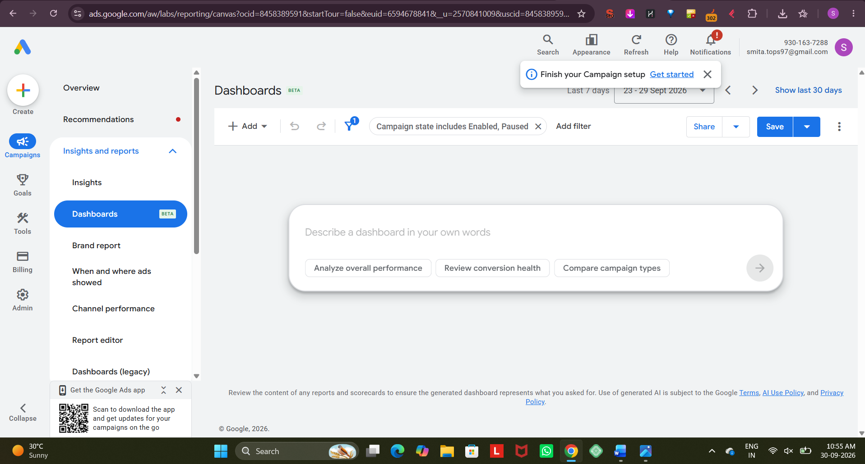
2. Three Campaign Types Available in Google Ads
1. Search Campaign
A Search Campaign displays text advertisements on Google Search when users search for relevant keywords.
Real-world example:
Zomato can run a Search Campaign for keywords such as “food delivery near me” or “order food online” to promote food delivery offers.
2. Display Campaign
A Display Campaign shows visual advertisements such as banners and images across websites and apps within Google's Display Network.
Real-world example:
Flipkart can use a Display Campaign to advertise its Big Billion Days sale with attractive banner ads on relevant websites and apps.
3. App Campaign
An App Campaign helps businesses promote their mobile applications and increase app installations or engagement.
Real-world example:
Spotify can run an App Campaign to encourage users to download the Spotify app and start using its music streaming services.

3. Campaign Objective
Selected Objective: Website Traffic
Website Traffic is useful for a brand like Myntra because it can bring more potential customers to the website.
Myntra can use Google Ads to target people searching for fashion products, clothing, shoes, and accessories.
The ads can direct users to relevant product or category pages.
This can increase website visits and provide more opportunities for users to explore and purchase products.

4. Keyword Match Types for “online food delivery”
Broad Match
online food delivery
Phrase Match
"online food delivery"
Exact Match
[online food delivery]
These match types control how closely a user's search needs to match the selected keyword before the advertisement can be considered for display.

5. Keywords for a Cricket Score App During IPL Season
The following keywords can be used for a campaign promoting a new cricket score app during the IPL season.
No. | Keyword | Match Type
1 | cricket score app | Broad Match
2 | live cricket score | Broad Match
3 | IPL live score | Broad Match
4 | "live cricket score app" | Phrase Match
5 | "IPL live score" | Phrase Match
6 | "cricket score app" | Phrase Match
7 | "live IPL score today" | Phrase Match
8 | [live cricket score] | Exact Match
9 | [IPL score today] | Exact Match
10 | [cricket score app] | Exact Match
Match-Type Summary
Broad Match:
- cricket score app
- live cricket score
- IPL live score
Phrase Match:
- "live cricket score app"
- "IPL live score"
- "cricket score app"
- "live IPL score today"
Exact Match:
- [live cricket score]
- [IPL score today]
- [cricket score app]
Conclusion
Google Ads provides different campaign types and keyword match types that help advertisers reach relevant audiences. Search, Display, and App campaigns can be selected according to the marketing goal. Proper keyword match types can help advertisers control how closely user searches should relate to their targeted keywords.

